CSNWH News …………July 15, 2025
It’s that time! Time to getting ready for the start of a new school year.
Important Dates
Parent Orientation 8/14 8:00 am
First Day of School 8/18 8:00 am
School Hours 8:00-3:00
Extended Care
Early Drop-off 7:30
Pick-up by 4:30

Uniforms
Uniform shirts and blouses are light blue
Pants, shorts, skirts and jumpers are navy blue
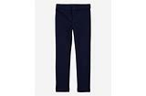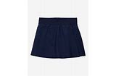All tops and jumpers must have the school logo.
Custom Embroidery will again provide the service.
1 item @ $10.00 3 items @ $25.00
You may drop the items here at school at any time starting now and they will get picked up and dropped off for your convenience. Payment must be submitted with the order. Place items in a bag and labeled with your child’s name on the outside.

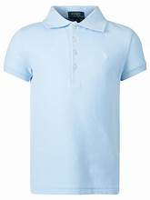



Parent Tip…
The most important tip for a parent to help create a successful year is to have your child at school on time. Remember how bad or odd you feel walking in to a meeting or class once it has started. Those feelings of inadequacy are also felt by your child when they walk in to a class in progress. The looks, stares and questions are difficult to endure. Arriving on time lets them know how important school is. While there will be times when arriving late just can’t be helped, start to develop the habit of getting to school on time a priority.
2025-2026 School Calendars
and
School Supply List for Elementary
Are on line at……… csnwh.org

